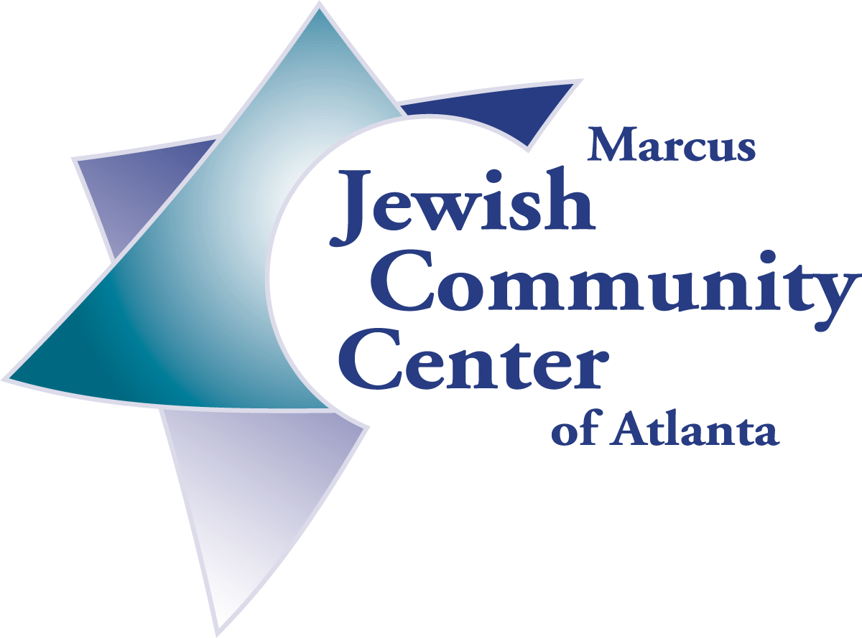

MJCCA Mission To Jewish Cuba!!!
A Jewish/Humanitarian Journey

Sponsored by International Community Builders, a volunteer program of the Marcus Jewish Community Center of Atlanta
in conjunction with the Jewish Cuba Connection Inc.

When: Monday June 16- Monday June 23, 2003
participants must be in Miami Sunday night June 15, 2003
Price: $2,175 for double occupancy (2,475 non MJCCA members)
$2,375 for single occupancy (2,675 non MJCCA members)
charter flight airfare from Miami
Includes:
- 7 nights at beautiful hotels
- Breakfast daily
- Dinner 6 nights
- All transportation to and from airport, and all tours which include Havana, Trinidad, Santa Clara, Cienfuegos
- Visit the Patronato, (the Cuban Jewish Community Center) Synagogues, Jewish cemeteries, art galleries, Hemingway’s fishing village, museums and more

Meet with Jewish community leaders
- Dine with members of the communities
- Professional English speaking tour guides
- Hotel taxes and service fees
- Tips (bellhops, guide and driver)
- Beautiful air conditioned bus (cold bottled water and facilities)
- Donation to the Jewish Communities
- Humanitarian License, Visa and Medical Insurance
Deposit: $500 per person with application due March 31,2003 Your deposit reserves your spot!
Your deposit of 500.00 is non-refundable. We strongly recommend travel insurance.
Applications accepted on the basis of first come first serve!

FINAL PAYMENT DUE:
May 30, 2003 (Make checks payable to the MJCCA)
(minimum 10 participants)
For applications or more information please contact:

Shaindle Schmuckler, Coordinator Volunteer/Community Services

Shaindle.Schmuckler@atlantajcc.org or 770 395 2540
Miriam Saul, Project manager
Miriam618@aol.com or 404 255 6652

